LAB 05: ARRAY, DUP, SOURCE INDEX
Dated: 29/09/2026

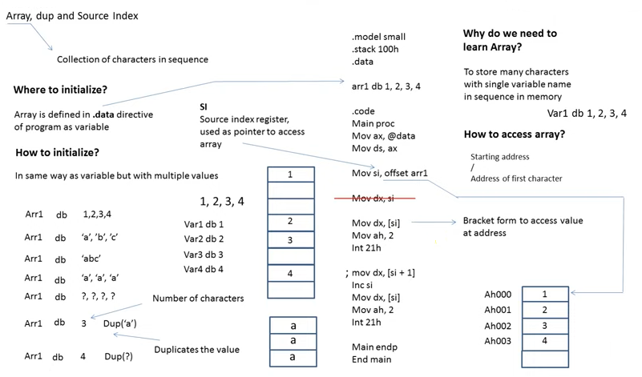

PROGRAM: Simple array, arraylab1.asm

dosseg

;if prog size is < 64KB then small model
.model small
.stack 100h

.data
arr1 db 1h,2h,3h,4h

.code
main proc
mov ax,@data
mov ds,ax

mov si,offset arr1
mov dx,[si]
mov ah,2
int 21h

;mov dx,[si+1]
inc si
mov dx,[si]
mov ah,2
int 21h

inc si
mov dx,[si]
mov ah,2
int 21h

inc si
mov dx,[si]
mov ah,2
int 21h

mov ah,4ch
int 21h

main endp
end main

---------------------------------------------

PROGRAM: Print an array using loop; arrlop.asm

dosseg

.model small
.stack 100h

.data
arr db 'a','b','c'

.code
main proc

mov ax,@data
mov ds,ax

mov si,offset arr

mov cx,3

l1:
mov dx,[si]

mov ah,2
int 21h

inc si
loop l1

mov ah,4ch
int 21h

main endp
end main

LAB 5 TASKS
Dated: 29/09/2026

LAB TASK 1: Write an AL program to print an array value on a specific index, for example print an array value on index 2.
LAB TASK 2: Using two different types of array, and print its values.

